|  |  |
| --- | --- |
| gateway_to_tech_logo_final.jpg | PLTW_M_L_4CP |

|  |
| --- |
| **Activity 6.3.1 Digital Number Systems** |

**Procedure**

In this activity you will practice converting letters to binary and then binary to decimal numbers.

**Decimal Numbers**

Decimal numbers or base-10 are the numbers you have been using since you learned to write numbers. The digits 0, 1, 2, 3, 4, 5, 6, 7, 8, 9, or combinations of those numbers are used to represent amounts.

**Binary Code**

The chart below demonstrates the two conditions that the Binary Code is based on:

|  |  |  |  |  |
| --- | --- | --- | --- | --- |
| 1 | On | High | True | Yes |
| 0 | Off | Low | False | No |

Communication in digital electrical devices is made up of a stream of 1s and 0s.

It is common for binary communication to occur in sets of 8 ones and zeros, as in the four examples seen below. A series of 8 ones and zeros is called a byte.

01000010 01111001 01110100 01100101

|  |  |  |
| --- | --- | --- |
| **Amount** | **Decimal** | **Binary** |
|  | 0 | 0000 |
| ☻ | 1 | 0001 |
| ☻☻ | 2 | 0010 |
| ☻☻☻ | 3 | 0011 |
| ☻☻☻☻ | 4 | 0100 |
| ☻☻☻☻☻ | 5 | 0101 |
| ☻☻☻☻☻☻ | 6 | 0110 |
| ☻☻☻☻☻☻☻ | 7 | 0111 |
| ☻☻☻☻☻☻☻☻ | 8 | 1000 |
| ☻☻☻☻☻☻☻☻☻ | 9 | 1001 |
| ☻☻☻☻☻☻☻☻☻☻ | 10 | 1010 |
| ☻☻☻☻☻☻☻☻☻☻☻ | 11 | 1011 |
| ☻☻☻☻☻☻☻☻☻☻☻☻ | 12 | 1100 |
| ☻☻☻☻☻☻☻☻☻☻☻☻☻ | 13 | 1101 |
| ☻☻☻☻☻☻☻☻☻☻☻☻☻☻ | 14 | 1110 |
| ☻☻☻☻☻☻☻☻☻☻☻☻☻☻☻ | 15 | 1111 |

**Converting Binary to Decimal**

* When you see a binary number, treat each one or zero as an individual.
* Example: 1010 would be pronounced one-zero-one-zero, NOT one thousand ten.
* Each digit represents a value.
* To move from binary to decimal, you simply add. Below there are 10 spots that could all be represented by a 1 or 0. If there is a 1 then add the value represented by that spot.

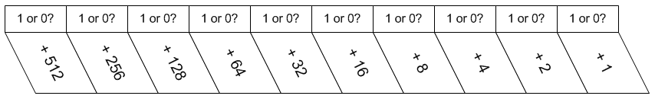

* Examine the decimal numbers:
* 13 (1101)
* 5 (101)
* 615 (1001100111)

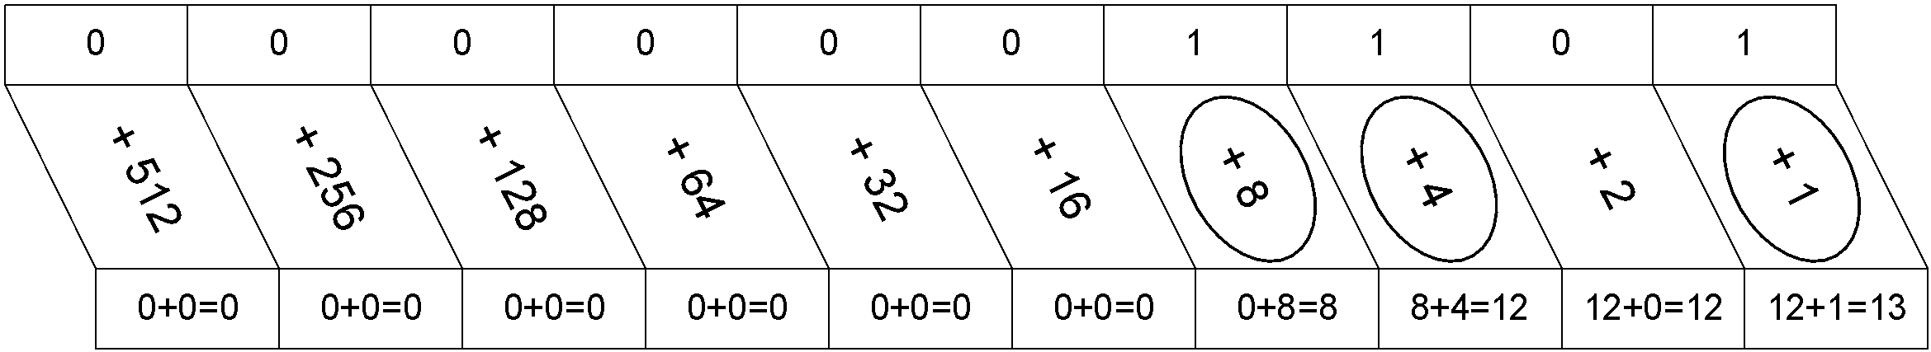

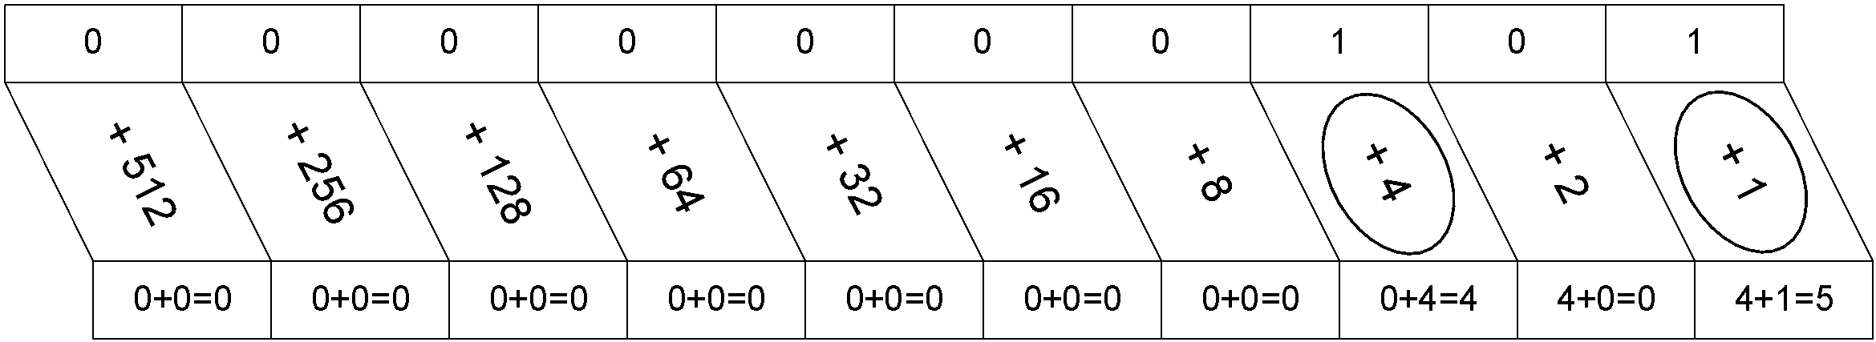

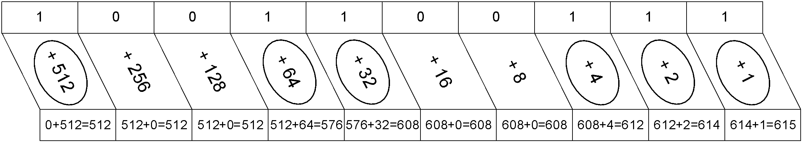

1. Using the method shown above, use the given tables to convert the binary numbers 1010001 and 110100 to decimal numbers.

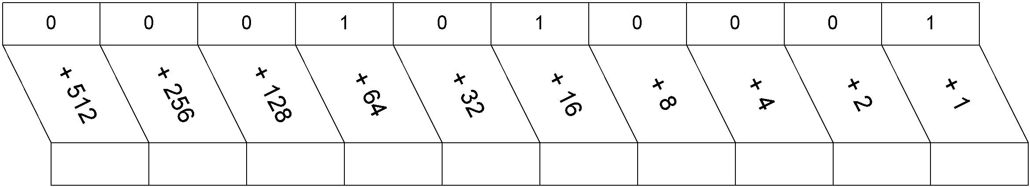

64 80 81

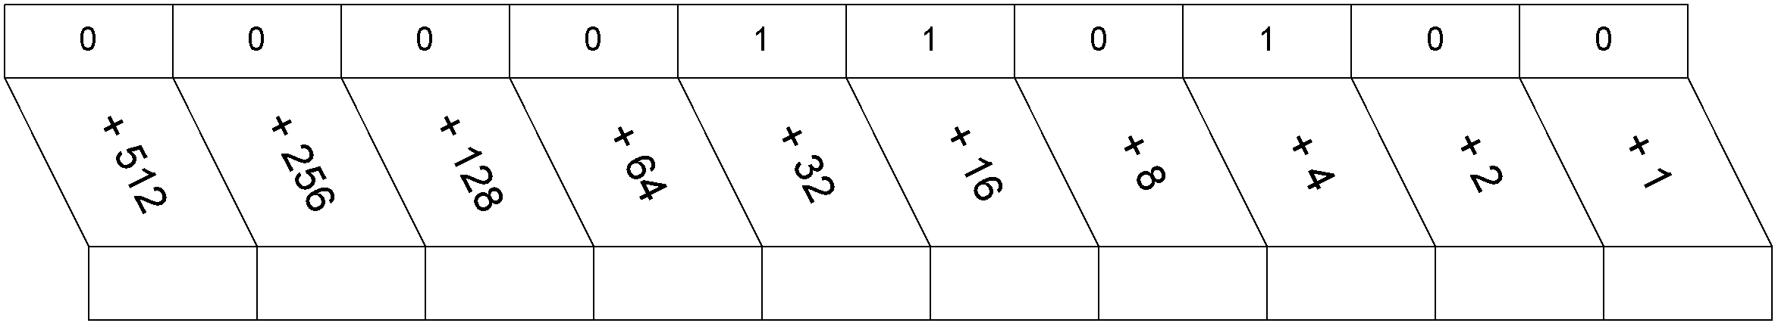

**32 48 52**

**ASCII Code**

Every character that you can create using the keyboard is sent as a series of 1s and 0s to the computer.

1. Write the first 5 letters of your name in the five vertical blanks of the Name column in the **Conversion Chart**. Be sure to capitalize the first letter.
2. Use the **ASCII Characters to Binary Numbers Chart** to translate the letters of your name to binary code in the **Conversion Chart**.
3. In the third vertical column of blanks, convert each binary code to decimal (base 10) using the method shown above.”

**Conversion Chart**

|  |  |  |
| --- | --- | --- |
| **Name Letters** | **Binary Code** | **Decimal**  **(base-10)** |
| D | 01000100 | 68 |
| e | 01100101 | 101 |
| v | 01110110 | 118 |
| o | 01101111 | 111 |
| n | 01101110 | 110 |

*Hint: Check your Base-10 answers by holding down the ALT key and typing your answer on the number pad of the computer.*

**ASCII Characters to Binary Numbers Chart**

|  |  |  |  |  |  |  |  |
| --- | --- | --- | --- | --- | --- | --- | --- |
| **A** | 01000001 | **a** | 01100001 | **0** | 00110000 | **!** | 00100001 |
| **B** | 01000010 | **b** | 01100010 | **1** | 00110001 | **“** | 00100010 |
| **C** | 01000011 | **c** | 01100011 | **2** | 00110010 | **#** | 00100011 |
| **D** | 01000100 | **d** | 01100100 | **3** | 00110011 | **$** | 00100100 |
| **E** | 01000101 | **e** | 01100101 | **4** | 00110100 | **%** | 00100101 |
| **F** | 01000110 | **f** | 01100110 | **5** | 00110101 | **&** | 00100110 |
| **G** | 01000111 | **g** | 01100111 | **6** | 00110110 | **‘** | 00100111 |
| **H** | 01001000 | **h** | 01101000 | **7** | 00110111 | **(** | 00101000 |
| **I** | 01001001 | **I** | 01101001 | **8** | 00111000 | **)** | 00101001 |
| **J** | 01001010 | **j** | 01101010 | **9** | 00111001 | **\*** | 00101010 |
| **K** | 01001011 | **k** | 01101011 |  |  | **+** | 00101011 |
| **L** | 01001100 | **l** | 01101100 |  |  | **,** | 00101100 |
| **M** | 01001101 | **m** | 01101101 |  |  | **/** | 00101111 |
| **N** | 01001110 | **n** | 01101110 |  |  | **-** | 00101101 |
| **O** | 01001111 | **o** | 01101111 |  |  | **:** | 00111010 |
| **P** | 01010000 | **p** | 01110000 |  |  | **;** | 00111011 |
| **Q** | 01010001 | **q** | 01110001 |  |  | **<** | 00111100 |
| **R** | 01010010 | **r** | 01110010 |  |  | **>** | 00111110 |
| **S** | 01010011 | **s** | 01110011 |  |  | **?** | 00111111 |
| **T** | 01010100 | **t** | 01110100 |  |  | **@** | 01000000 |
| **U** | 01010101 | **u** | 01110101 |  |  | **[** | 01011011 |
| **V** | 01010110 | **v** | 01110110 |  |  | **]** | 01011101 |
| **W** | 01010111 | **w** | 01110111 |  |  | **^** | 01011110 |
| **X** | 01011000 | **x** | 01111000 |  |  | ***space*** | 00100000 |
| **Y** | 01011001 | **y** | 01111001 |  |  |  |  |
| **Z** | 01011010 | **z** | 01111010 |  |  |  |  |

**Conclusion**

1. If the base-10 system stops with the number 9, then why isn’t it called base-9?

Because 0 is a number and included in base-10.

1. Music, television, and radio all can be digital. What does that have to do with the way signals are transmitted and received?

It means that everything that is transmitted is in binary.

1. Internet speed is measured in bits per second. In the task bar of your computer, let the mouse pointer hover over the icon that shows your connection speed. What does it say? What does that have to do with one byte being a combination of 8 ones and zeros and the speed of your connection?

33.9 Mb/s. It means that it can send and receive 33,900,000 bytes, each byte being 8 bits/ones or zeros. So the computer can send/receive 271,200,000 bits per second.